Wideband Delphi Technique
# Source: AI Source: Provided by: [Data Path: Persons Table -> ID Column: 1, Name_En Column: Motasem Essam] -> From: [Chatgpt (GPT‑5 Mini)] on [8/24/2025]
Great that you brought this up 🙌 — Wideband Delphi is closely related to the Expert-Based (Expert Judgment) technique, but it improves it by reducing bias and increasing accuracy. Let’s break it down:

📌 What is Wideband Delphi Technique?
# Source: AI Source: Provided by: [Data Path: Persons Table -> ID Column: 1, Name_En Column: Motasem Essam] -> From: [Chatgpt (GPT‑5 Mini)] on [8/24/2025]
Wideband Delphi is a consensus-based estimation technique where multiple experts independently estimate the effort/time, then discuss their estimates as a group, and repeat the process until they converge on an agreed estimate.
👉 Think of it as Expert Judgment + Structured Group Discussion.

🗂️ Steps in Wideband Delphi
# Source: AI Source: Provided by: [Data Path: Persons Table -> ID Column: 1, Name_En Column: Motasem Essam] -> From: [Chatgpt (GPT‑5 Mini)] on [8/24/2025]
- Select Experts
  - A group of domain experts, senior testers, developers, or project managers.
- Distribute Information
  - Provide project scope, requirements, and assumptions to all participants.
- Round 1: Individual Estimates
  - Each expert privately gives an estimate (no group influence yet).
- Discussion Round
  - Experts review results together, discuss differences, justify reasoning.
- Round 2: Refined Estimates
  - After discussion, each expert revises their estimate.
- Repeat until Consensus
  - Usually after 2–3 rounds, estimates converge to a reliable number.

📊 Example of Wideband Delphi
# Source: AI Source: Provided by: [Data Path: Persons Table -> ID Column: 1, Name_En Column: Motasem Essam] -> From: [Chatgpt (GPT‑5 Mini)] on [8/24/2025]
Suppose estimating testing effort for an e-commerce checkout module:
- Round 1 Estimates:
  - Expert A = 120 hrs
  - Expert B = 180 hrs
  - Expert C = 150 hrs
- Discussion:
  - Expert A says: “I assumed no performance testing.”
  - Expert B says: “I included security testing.”
  - Expert C: “I only counted functional testing.”
- Round 2 Estimates (after clarifications):
  - Expert A = 160 hrs
  - Expert B = 170 hrs
  - Expert C = 165 hrs
✅ Final Consensus = 165–170 hrs

✅ Advantages of Wideband Delphi
# Source: AI Source: Provided by: [Data Path: Persons Table -> ID Column: 1, Name_En Column: Motasem Essam] -> From: [Chatgpt (GPT‑5 Mini)] on [8/24/2025]
- More accurate than single expert judgment.
- Reduces personal bias (since multiple experts contribute).
- Promotes team collaboration.
- Works well when requirements are unclear.

⚠️ Disadvantages
# Source: AI Source: Provided by: [Data Path: Persons Table -> ID Column: 1, Name_En Column: Motasem Essam] -> From: [Chatgpt (GPT‑5 Mini)] on [8/24/2025]
- Takes more time (multiple rounds).
- Needs several experts, not always available.
- Risk of groupthink (people aligning too easily).

🔑 Difference: Expert Judgment vs Wideband Delphi
# Source: AI Source: Provided by: [Data Path: Persons Table -> ID Column: 1, Name_En Column: Motasem Essam] -> From: [Chatgpt (GPT‑5 Mini)] on [8/24/2025]
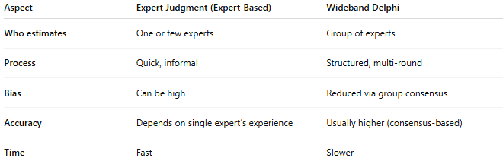
Aspect | Expert Judgment (Expert-Based) | Wideband Delphi
Who estimates | One or few experts | Group of experts
Process | Quick, informal | Structured, multi-round
Bias | Can be high | Reduced via group consensus
Accuracy | Depends on single expert’s experience | Usually higher (consensus-based)
Time | Fast | Slower

👉 So, you can think of Wideband Delphi as a “team version” of Expert-Based estimation.

